**Brain Annotation Toolbox User Manual v1.1**

1. **Software Description, Installation and Setup** 
   1. ***Description***

Based on the activation maps from Neurosynth (http://neurosynth.org/) and the gene expression data from the Allen Human Brain Atlas (http://human.brain-map.org/), the Brain Annotation Toolbox (BAT) provides methods to perform functional and genetic annotation analysis for neuroimaging results.

* 1. ***Hardware and Software Requirements***

*Matlab*

The BAT requires at least Matlab 2015b.

*SPM*

The BAT requires that SPM8 or a more recent version has been installed on your computer

*Operating system*

The toolbox has been evaluated on the Windows platform.

We will adapt and evaluate it on other systems in the future.

* 1. ***Program Installation***

The BAT can be obtained at http://istbi.fudan.edu.cn/bat/index.html.

After decompressing the ‘BAT_V1.1.rar’ file, add the path to the BAT to your Matlab work path, and make sure that the SPM toolbox is in your path, with commands in Matlab that might be along the following lines:

Use Matlab with the SetPath icon in the task bar to set the path with subfolders to your SPM directory and your BAT directory.

(Calls are made to SPM to read in data files.)

To start BAT, type ‘BAT’ in the Matlab command window.

* 1. ***Referencing the software***

When using this toolbox please cite:

***Zhaowen Liu et.al. The functional and genetic associations of neuroimaging data: a toolbox. 2017. In preparation.***

The above manuscript provides a description of the methods BAT uses to perform functional and genetic annotation analysis.

1. **Using the BAT**
   1. ***GUI layout***
2. *The main page*

Two buttons are present on the page for the user to choose.

If you wish to perform annotation analysis on the brain parcellations or clusters, press the ‘Region/cluster Analysis’.

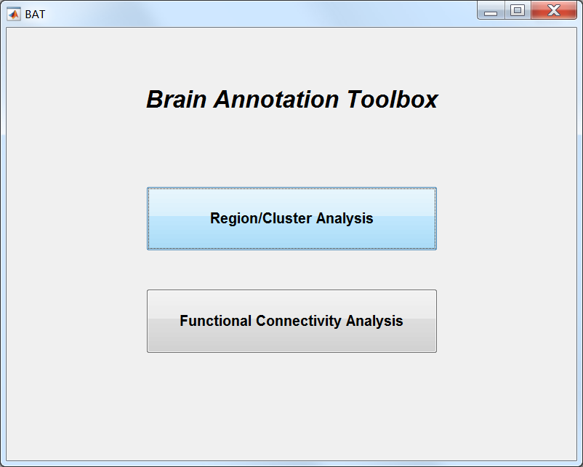If you wish to perform annotation analysis for functional connectivity (FC), either for brain networks with several FC links for or single FCs, press the ‘Functional connectivity Analysis’ Button.

**Fig.1 The main page of BAT**

1. *The region/cluster analysis page*

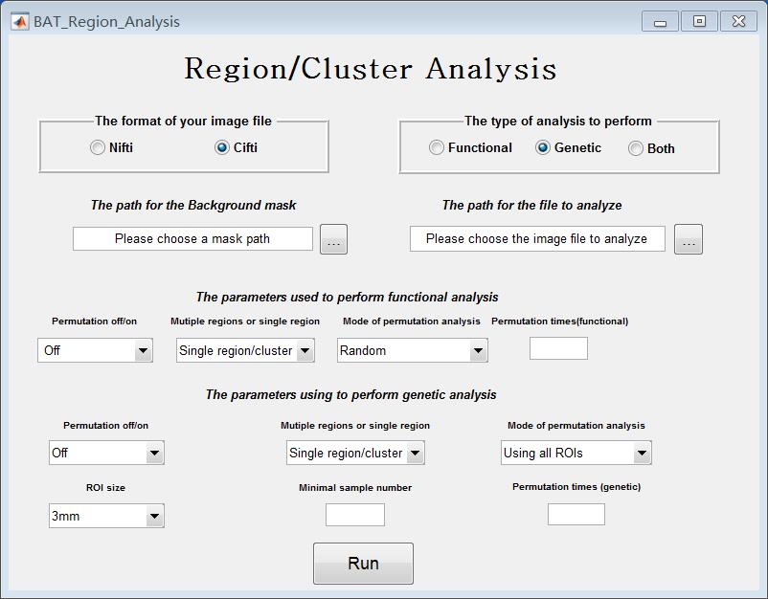The page is provided for users to set the parameters to perform functional and genetic annotation for regions/clusters (see Figure 2)

**Fig.2 The region/cluster analysis page**

We use two examples in ***2.2*** and ***2.3*** to show how to set the parameters for brain region analysis (where the region might be from an atlas), or for a cluster of voxels reflecting an activation from a neuroimaging investigation.

1. *The functional connectivity (FC) analysis page*

Users can use this page to set the parameters to perform functional and genetic annotation for FCs (see Figure.3).

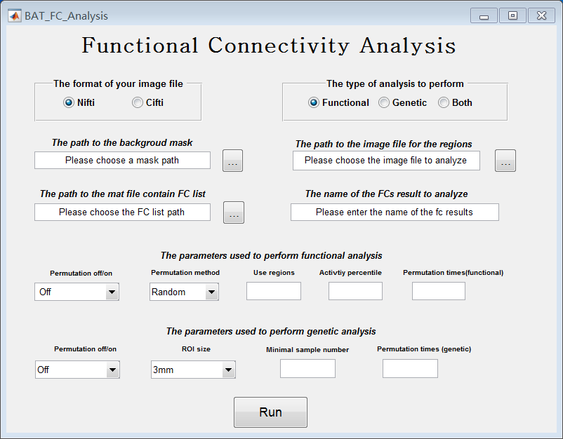

**Fig.3 The functional connectivity analysis page**

In ***2.4***, we use an example to show how to set the parameters for functional and genetic annotation analysis for FCs.

* 1. ***An example of the use of BAT to provide functional and genetic annotation for all brain regions identified with an atlas such as Brodmann***

Here is an example to illustrate how to use BAT to perform functional and genetic annotation analysis for all brain region in an atlas. Here we use Brodmann areas as an example. Follow the instructions below to perform the analysis.

1. Open Matlab and set ‘BAT_V1.1’ as your working directory.
2. Type ‘BAT’ in the command window and press the ‘Region/Cluster Analysis’ button.
3. Setting the analysis parameters
4. Choose ‘Nifti’ as the format of your image files;
5. Choose ‘Both’ as the type of analysis to perform;
6. Set the path for the background mask as ‘~\BAT_V1.1\test_image\Reslice_BrainMask_05_91x109x91.img;
7. Set the path for the file to analyze as ‘~\BAT_V1.1\test_image\brodmann.nii
8. Setting the parameters for **functional annotation**
9. Set the permutation off/on as ‘on’.
10. Set the multiple regions or single region as ‘Multiple regions/clusters’.
11. Set the mode of permutation analysis to ‘clusters’.
12. Set the permutation times (functional) as 100. (You can use a large permutation times number to obtain more reliable results, but it may need tens of minutes to run).
13. Setting the parameters for **genetic analysis**
14. Set the permutation off/on as ‘on’
15. Set the ROI size as ‘6mm’
16. Set the multiple regions or single region as ‘Multiple regions/clusters’.
17. Set the mode of permutation analysis as ‘Excluding ROIs belonging to the region’. In this mode, the BAT will use all the gene expression ROIs from the Allen Human Brain Atlas, excluding mapping to the region being analyzed to perform further permutation analysis.
18. Set the minimal sample number as 5.
19. Set the permutation times as 100.
20. **If you want to use the 3D-visualization function of BAT to visualize your annotation results. You should prepare a excel to indicate the name of the regions/clusters that you labeled using numbers in the image you provide to BAT.** In the case, you should copy the file named as ‘brodmann_region_name.xlsx’ in the folder ‘test_image’ to the folder ‘VBrain\Visual_files\BAT_Vistrans’ and renamed the files as ‘Region.xlsx’. (For your own analysis, you should prepare a ‘.xlsx’ file named as ‘Rergion.xlsx’ using the same format as the example files. The first column lists the numbers used to label the regions/clusters in the provided imaging file, and the second column provide the names of the corresponding regions/clusters.)
21. Press the ‘Run’ button.
22. 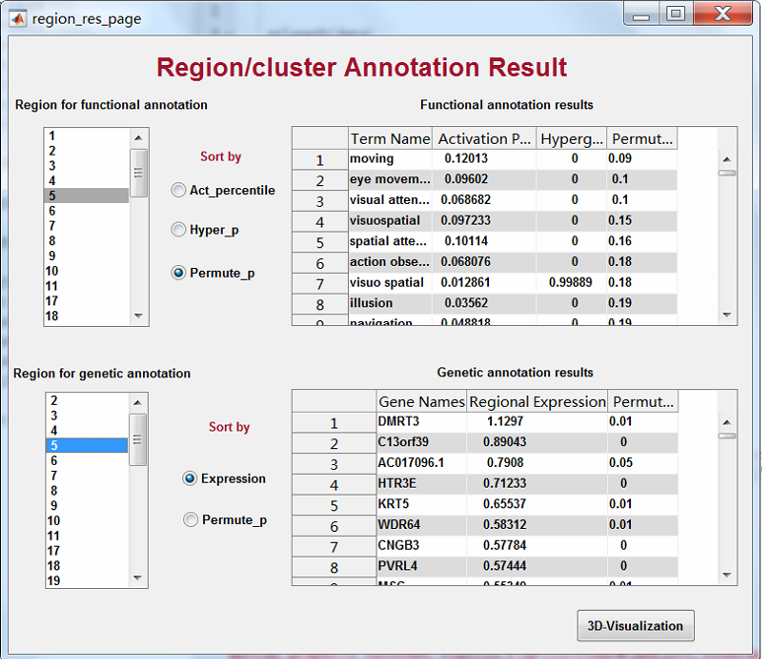A result page will pop up (see figure 4). You can select the region from the left list to obtain

**Fig.4 The result page for the Brodmann areas**

their functional and genetic annotation results. For the Brodmann atlas, the numbers in this list correspond to BA areas. The way to order the annotation results can also be set by selecting different sorting methods provided in the middle of the page. Hypergeometric_P is the p value for the hypergeometic test; Permutation is the p-value for the permutation test.

1. 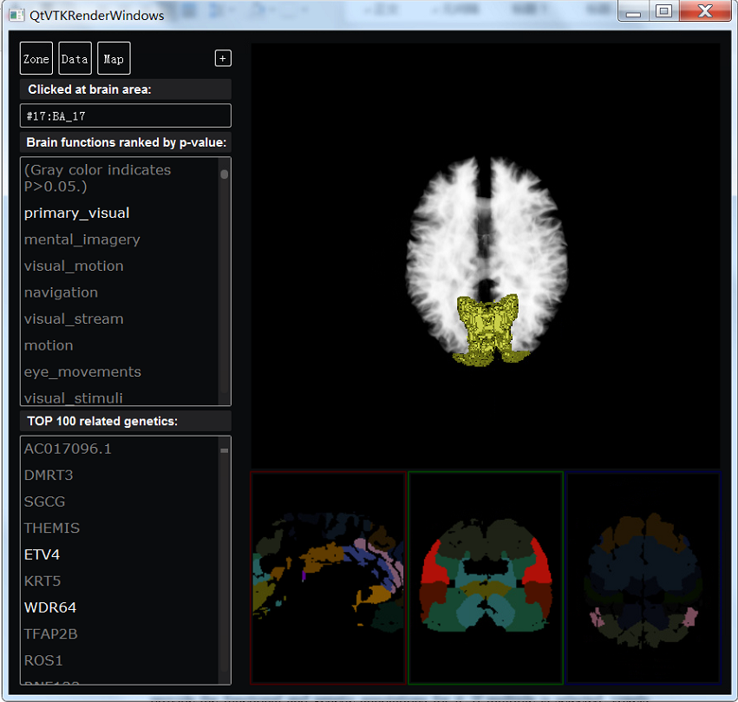A 3-D visualization for the functional and genetic annotation results is also provided. You can press the ‘3-D visualization’ button on the result page to get the visualization platform to work. A new window will be created and you can click the position that you are interested in at the three windows in the bottom to obtain its functional and genetic annotation results (see figure5). The results are also provided in ~\BAT_V1.1\Region_Results\reg_func_res.mat and reg_genetic_res.mat.

**Fig.5 The 3-D visualization for annotation results for Brodmann areas**

* 1. ***Example for using BAT to provide functional and genetic annotation for clusters obtained from task-related or disease-related neuroimaging analysis***

Here is an example on using the BAT to perform functional and genetic annotation analysis for clusters that are activated in a specific task or are found related to a brain disease. Here we use the autism-related cluster obtained from the brain-wide association analysis (BWAS) as an example. You need follow the below instruments step by step to perform the analysis.

1. Open Matlab and set the ‘BAT_V1.1’ as your working directory.
2. Type ‘BAT’ in command window and press the ‘Region/Cluster Analysis’ button.
3. Setting the analysis parameters
4. Choose the ‘Nifti’ as the format of your image files;
5. Choose ‘Both’ as the type of analysis to perform;
6. Set the path for the background mask as ‘~\BAT_V1.1\test_image\Reslice_BrainMask_05_91x109x91.img;
7. Set the path for the file to analyze as ‘~\BAT_V1.1\test_image\ autism_cluster.nii’
8. Setting the parameters for functional analysis
9. Set the permutation off/on as ‘on’.
10. Set the multiple regions or single region as ‘Single region/cluster’. (The effect of this is to treat all activated voxels (voxels with non-zeros values) as one cluster, and to provide the functional and genetic annotations for it. If multiple is selected, voxels belong to each cluster must be labeled with different numbers. In the result page, the numbers use to label the clusters will be used to represent them.)
11. Set the mode of permutation analysis as ‘clusters.’
12. Set the permutation times as 100. (You can use a large permutation times to get more reliable results but it may need tens of minutes to run).
13. Setting the parameters for genetic analysis
14. Set the permutation off/on as ‘on’.
15. Set the ROI size as ‘6mm’
16. Set the multiple regions or single region as ‘Single region/cluster’.
17. Set the mode of permutation analysis as ‘Excluding ROIs belong to the region’.
18. Set the ROI size as ‘6mm’.
19. Set the minimal sample number as ‘5’.
20. Set the permutation times as ‘100’.
21. If you want to use the 3D-visualization function of BAT to visualize your annotation results. In the case, you should copy the file named as ‘autism_region_name.xlsx’ in the folder ‘test_image’ to the folder ‘~\BAT_V1.1\VBrain\Visual_files\BAT_Vistrans’ and renamed it as ‘Region.xlsx’.
22. Press the ‘Run’ button.
23. 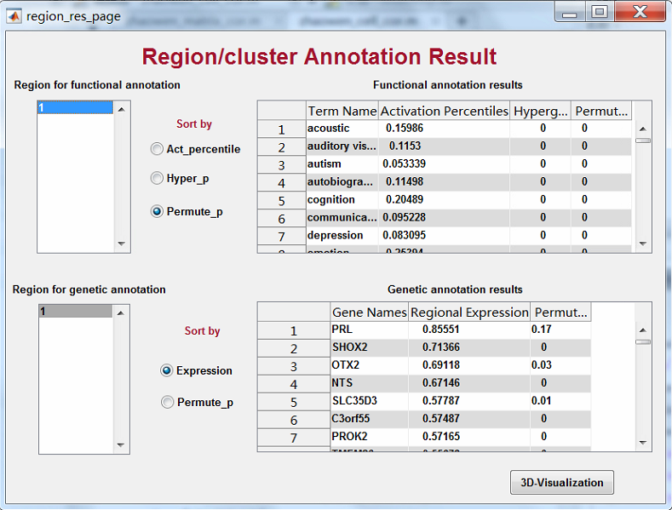A result page will pop (see figure 6). You can choose the regions from the list in the left to obtain their functional and genetic annotation results. The way to order the annotation results can also be set by selecting different sorting methods provided in the middle of the page.

**Fig.6 The result page for the Autism related clusters**

1. 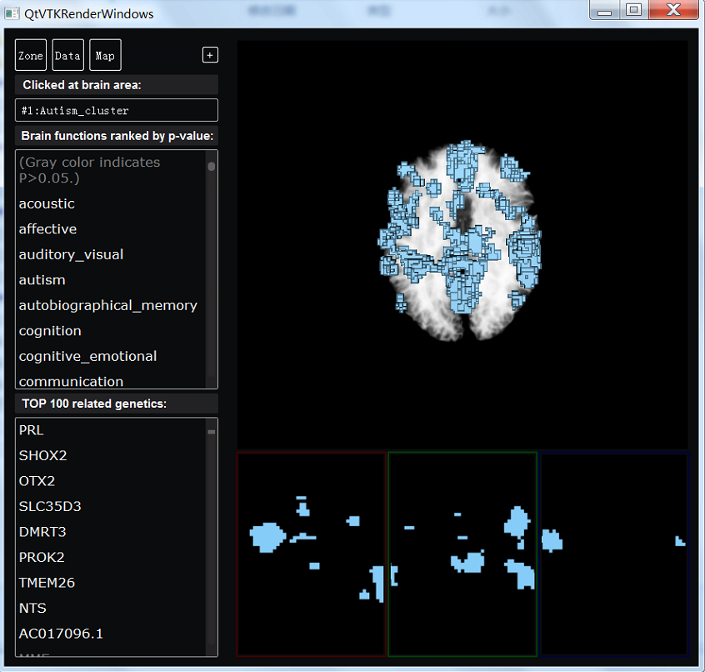A 3-D visualization for the functional and genetic annotation results is also provided. You can press the ‘3-D visualization’ button on the result page to get the visualization platform to work. A new window will be created and you can click the position that you are interested in at the three windows in the bottom to obtain its functional and genetic annotation results. The results are also provided in ~\BAT_V1.1\Region_Results\reg_func_res.mat and reg_genetic_res.mat.

**Fig.7 The 3-D visualization for annotation results of the Autism related clusters**

* 1. ***Example for Functional Connectivity (FC) Analysis***

An input ‘. nii’ file is typically provided that contains either voxel clusters to represent the nodes for the FC analysis, or an AAL2 or similar atlas, together a file that contains a list of the pairs of nodes to identify each FCs to be annotated. Examples of these files are provided and are used in the following example, and further details about how to construct these files are provided in the paper.

Here is an example on using the BAT to perform functional and genetic annotation analysis for the results in the format of FCs. You need follow the instructions below to perform the analysis.

1. Open Matlab and set the ‘BAT_V1.1’ as your work directory.
2. Type ‘BAT’ in the command window and press the ‘Functional Connectivity Analysis’ button.
3. Setting the analysis parameters
4. Choose the ‘Nifti’ as the format of your image files;
5. Choose ‘Both’ as the type of analysis to perform;
6. Set the path to the background mask as ‘~\BAT_V1.1\test_image\Reslice_BrainMask_05_91x109x91.img;
7. Set the path to the image file for the regions as ‘~\BAT_V1.1\test_image\Reslice_AAL2.nii’ \
8. Set the path to the mat file that contains the FC list as ‘~\BAT_V1.1\test_image\fc_res’
9. Set the name of the FCs result to analyze as ‘fc_res’
10. Setting the parameters for functional analysis
11. Set the permutation off/on as ‘on’.
12. Set the permutation method as ‘Parcellation’.
13. Set the use regions ‘1:94’.
14. Set the activity percentile as ‘0’.
15. Set the permutation times as 100. (You can use a large permutation times to get more reliable results but it may need tens of minutes to run).
16. Setting the parameters for functional analysis
17. Set the permutation off/on as ‘on’.
18. Set the ROI size as ‘6mm’.
19. Set the minimal sample number ‘5’.
20. Set the mode of permutation analysis as ‘Excluding ROIs belong to the region’.
21. Set the permutation times as 100.
22. Press the ‘Run’ button.
23. 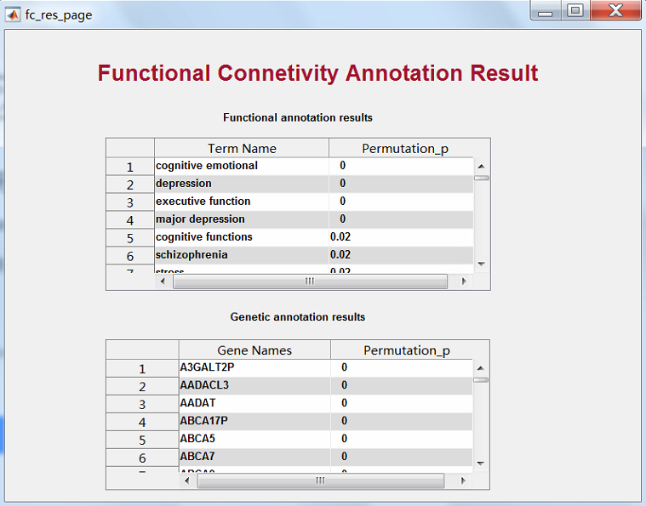A result page will pop to provide the functional and genetic annotation results (See figure 7). The results are also provided in ~\BAT_V1.1\FC_Results\reg_func_res.mat and reg_genetic_res.mat.

**Fig.7 The result page for the functional connectivity analysis example**

1. **Further information.**

3.1. You should resample your result image to 1 × 1 × 1 mm3 before fed it into BAT.

3.2. Although a GUI is provided to run the BAT, individual analyses can be performed from the matlab command line. The functions that are available are in the BAT_fun subdirectory.

3.3 Only for the analysis that performs both of functional and genetic annotation, the result page will pop in the end of the analysis and the 3D visualization is available. For the analysis that only perform functional or genetic annotation, you can obtained the result from the saved .mat files.

1. **Help:**

If the program fails to run, make sure that you have closed windows from a previous run and are in the BAT directory.

If a window hangs, use the task manager to stop any BAT-related process that is using excessive CPU time.

1. **Contact information:**

Email: liukaka928@126.com